SECTION-03

3.1

SELECT ename,jobid,salary

FROM employ

WHERE jobid>6000 AND salary>3000000;

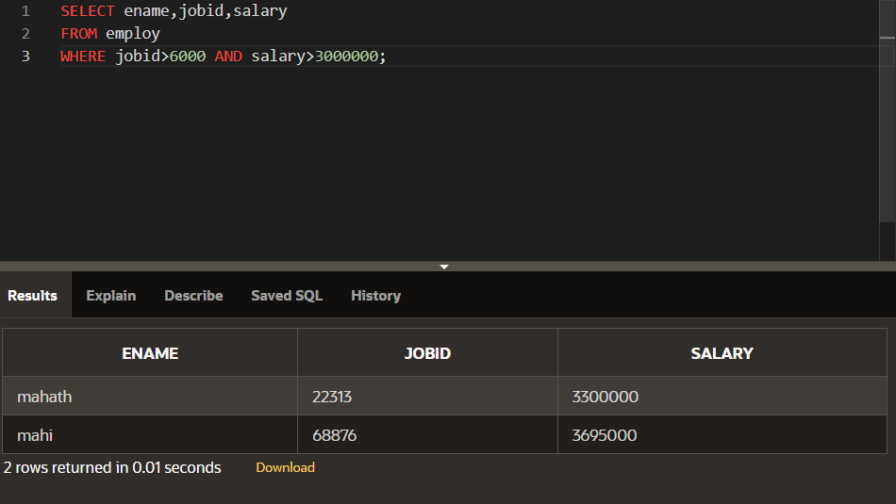

SELECT ename,jobid,salary

FROM employ

WHERE jobid>6000 OR salary>3000000;

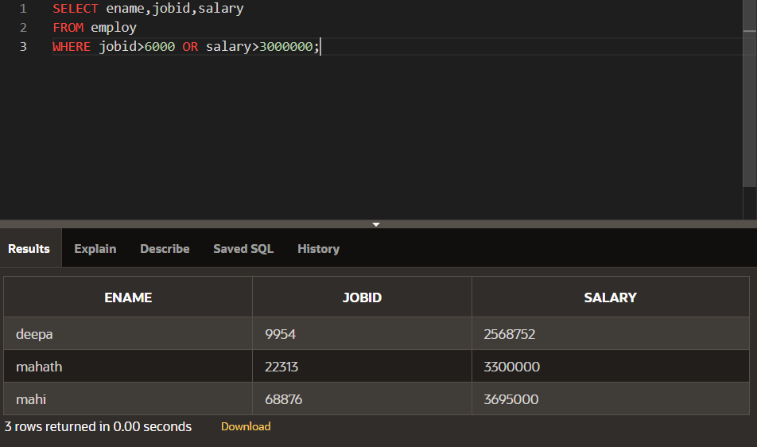

SELECT eno,ename

FROM employ

WHERE eno NOT IN (02,03);

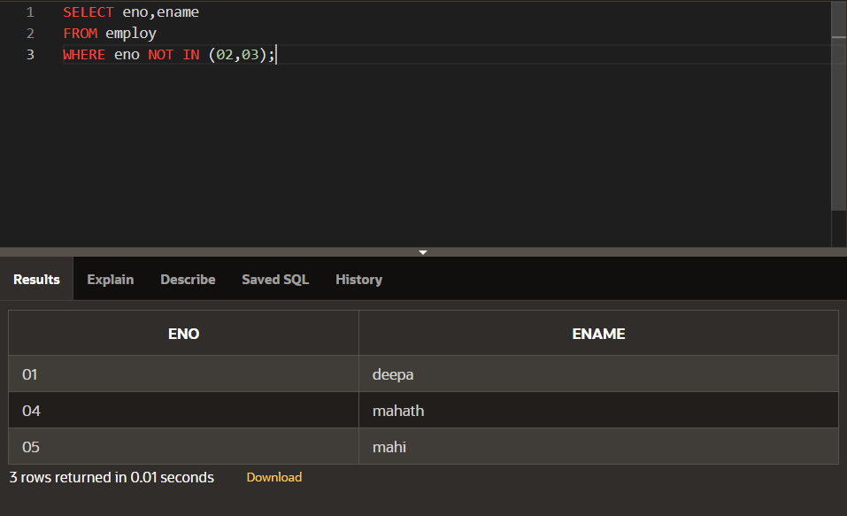

SELECT eno||' '||salary\*2 AS "Employee salary"

FROM employ

WHERE eno IN (03,05) AND ename LIKE 'm%' OR ename LIKE '%a%';

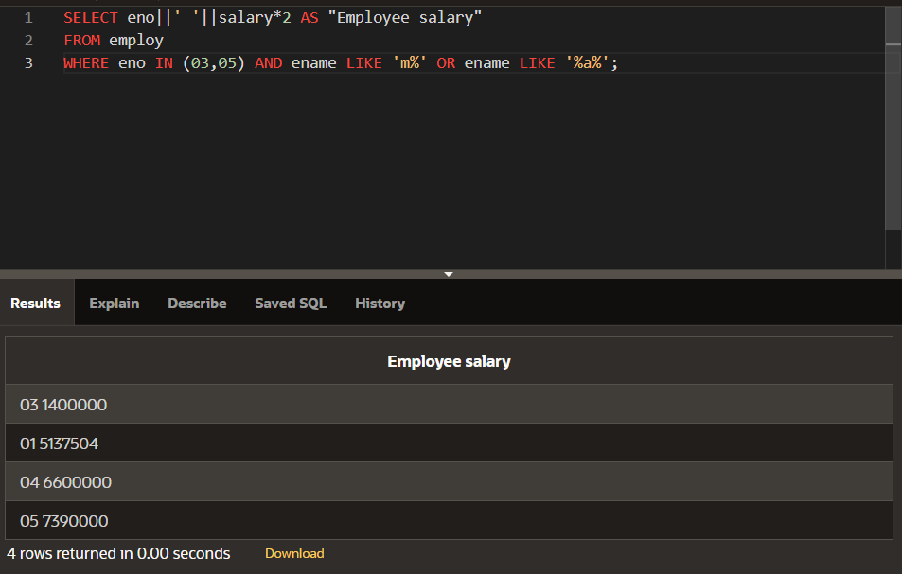

3.2

SELECT eno,ename

FROM employ

ORDER BY eno;

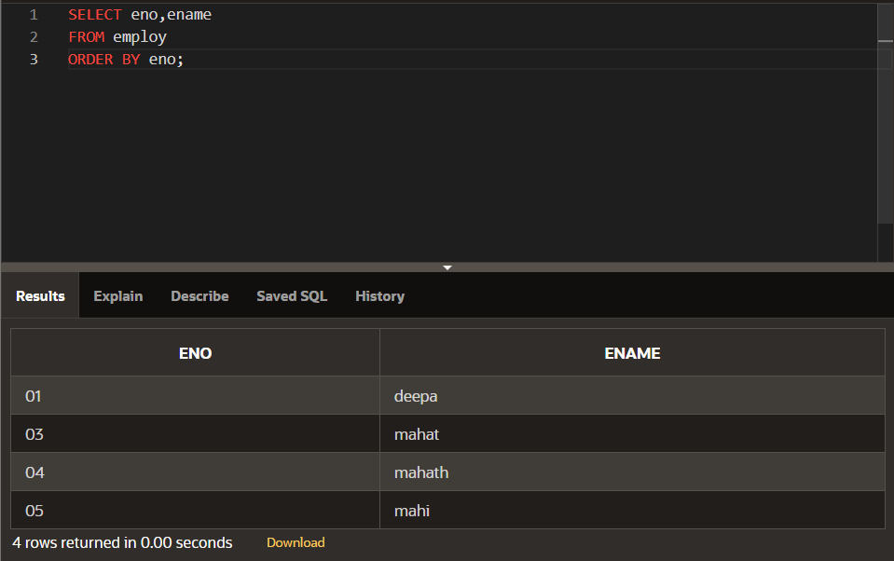

SELECT eno,ename

FROM employ

ORDER BY eno DESC;

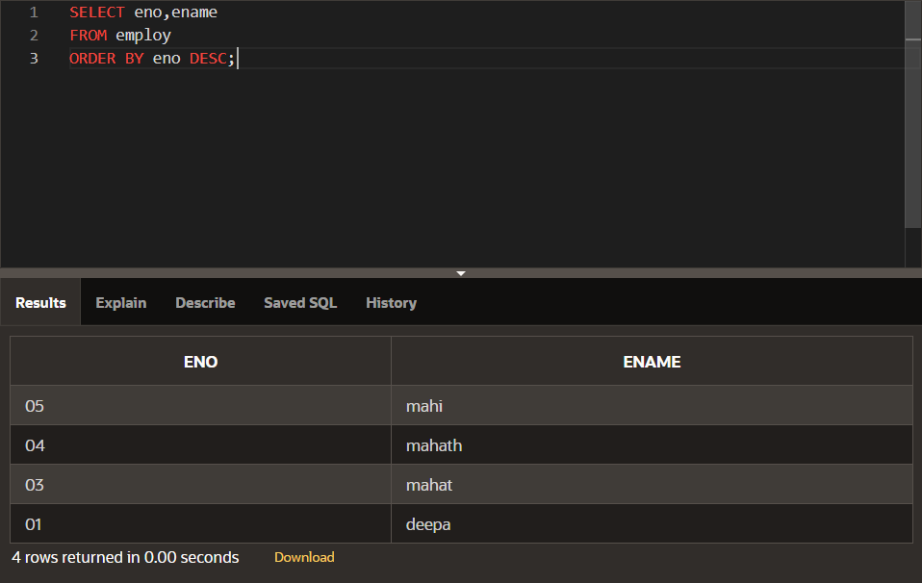

SELECT eno AS "Employee Num",ename

FROM employ

ORDER BY "Employee Num";

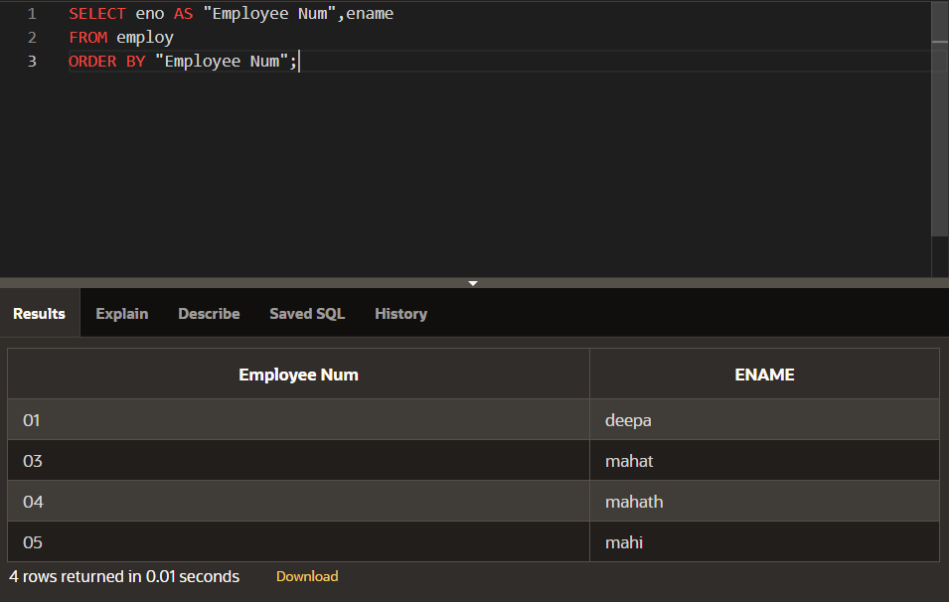

SELECT eno,ename

FROM employ

WHERE eno<03

ORDER BY ename;

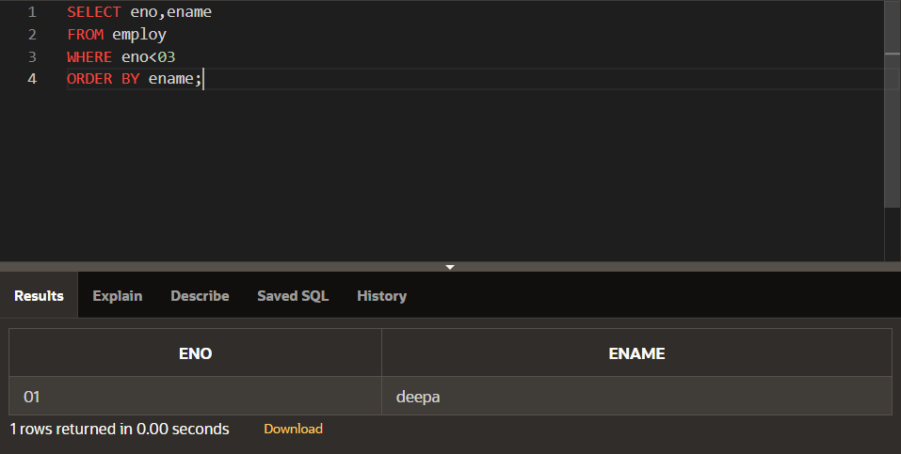

SELECT eno,ename

FROM employ

WHERE eno<=03

ORDER BY eno,ename;

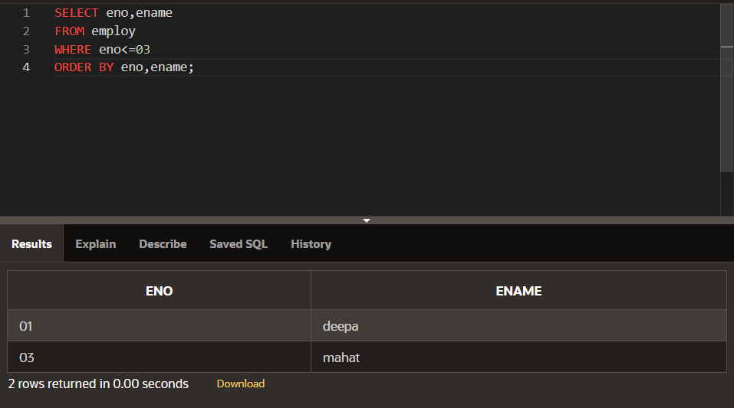

SELECT eno,ename

FROM employ

WHERE eno<=03

ORDER BY eno DESC,ename;

